Let us Host your Next Party
www.vpnewrecruits.weebly.com
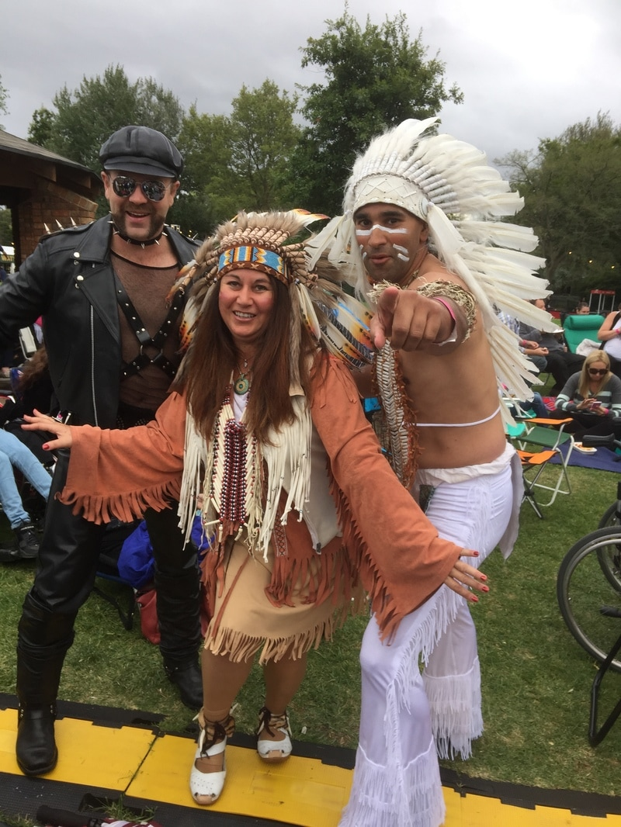 |  | Party Theme Options include  “Blankety Blanks” Game Show & Trivia / Quiz Nights  Live music & Karaoke / Lip Sync Battles  Charity Fundraisers  Themed or Costume Parties  Ask about our “Village People Experience” as a part of your night  For information and a great night please contact us  Call or SMS 0427 185 185  Email : jay_whitefeather@hotmail.com

